**Institute of Information Technology (IIT)**

Jahangirnagar University



**Lab Report: 08**

Submitted by:

Name: Md. Shakil Hossain  
Roll No: 2023

Lab Date: 28/08/2023  
Submission Date: 03/09/2023

K-Means Clustering

K-Means Clustering is an Unsupervised Learning algorithm, which groups the unlabeled dataset into different clusters. Here K defines the number of pre-defined clusters that need to be created in the process, as if K=2, there will be two clusters, and for K=3, there will be three clusters, and so on.

“It is an iterative algorithm that divides the unlabeled dataset into k different clusters in such a way that each dataset belongs only one group that has similar properties.”

It allows us to cluster the data into different groups and a convenient way to discover the categories of groups in the unlabeled dataset on its own without the need for any training.

It is a centroid-based algorithm, where each cluster is associated with a centroid. The main aim of this algorithm is to minimize the sum of distances between the data point and their corresponding clusters.

**The k-means clustering algorithm mainly performs two tasks:**

* Determines the best value for K center points or centroids by an iterative process.
* Assigns each data point to its closest k-center. Those data points which are near to the particular k-center, create a cluster.

Hence each cluster has datapoints with some commonalities, and it is away from other clusters.

The below diagram explains the working of the K-means Clustering Algorithm:

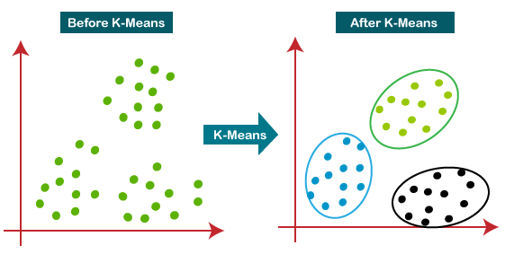

**How does the K-Means Algorithm Work?**

The working of the K-Means algorithm is explained in the below steps:

Step-1: Select the number K to decide the number of clusters.

Step-2: Select random K points or centroids. (It can be other from the input dataset).

Step-3: Assign each data point to their closest centroid, which will form the predefined K clusters.

Step-4: Calculate the variance and place a new centroid of each cluster.

Step-5: Repeat the third steps, which means reassign each datapoint to the new closest centroid of each cluster.

Step-6: If any reassignment occurs, then go to step-4 else go to FINISH.

Step-7: The model is ready.

When using the Kmeans algorithm under normal circumstances, it is because you don't have labels. In this case we will use the labels to try to get an idea of how well the algorithm performed, but you won't usually do this for Kmeans, so the classification report and confusion matrix at the end of this project, don't truly make sense in a real world setting!.

**Connectivity-based clustering**

* Distance based
* E.g., Hierarchical clustering

**Centroid-based clustering**

* Represents each cluster by a single mean vector
* E.g., k-means algorithm

**Distribution-based clustering**

* Modeled using statistical distributions
* E.g., Multivariate normal distributions used by the expectation-maximization algorithm.

**Density-based clustering**

* Defines clusters as connected dense regions in the data space.
* E.g., DBSCAN

**Source of the data**

https://www.kaggle.com/datasets/karthikthallam/college-data/code

# Import libraries

In [1]:

**import** numpy **as** np *# linear algebra*

**import** pandas **as** pd *# data processing, CSV file I/O (e.g. pd.read_csv)*

**import** matplotlib.pyplot **as** plt *# for data visualization*

**import** seaborn **as** sns *# for statistical data visualization*

**%**matplotlib inline

In [3]:

df **=** pd.read_csv('../Resource/College.csv')

# Exploratory data analysis

In [4]:

df.shape

Out[4]:

(777, 19)

In [5]:

df.head()

Out[5]:

**0**

|  |  |  |  |  |  |  |  |  |  |
| --- | --- | --- | --- | --- | --- | --- | --- | --- | --- |
| **Unnamed: Private** | | | **Apps** | **Accept** | **Enroll** | **Top10perc** | **Top25perc** | **F.Undergrad** | **P.Undergr** |
| Abilene  **0** Christian Yes University | | | 1660 | 1232 | 721 | 23 | 52 | 2885 | 5 |
| **1** Adelphi Yes | | | 2186 | 1924 | 512 | 16 | 29 | 2683 | 12 |
| **2** Adrian Yes | | | 1428 | 1097 | 336 | 22 | 50 | 1036 |  |
| Agnes  **3** Scott Yes | | | 417 | 349 | 137 | 60 | 89 | 510 |  |
|  | College |  |  |  |  |  |  |  |  |
| **4** | Alaska Pacific | Yes | 193 | 146 | 55 | 16 | 44 | 249 | 8 |
|  | University |  |  |  |  |  |  |  |  |

University College

In [6]:

df.info()

<class 'pandas.core.frame.DataFrame'> RangeIndex: 777 entries, 0 to 776

Data columns (total 19 columns):

# Column Non-Null Count Dtype

|  |  |  |  |  |  |  |  |
| --- | --- | --- | --- | --- | --- | --- | --- |
| 0 |  | Unnamed: | 0 | 777 | non-null |  | object |
| 1 |  | Private |  | 777 | non-null |  | object |
| 2 |  | Apps |  | 777 | non-null |  | int64 |
| 3 |  | Accept |  | 777 | non-null |  | int64 |
| 4 |  | Enroll |  | 777 | non-null |  | int64 |
| 5 | Top10perc | | | 777 | non-null | int64 | |
| 6 | Top25perc | | | 777 | non-null | int64 | |
| 7 | F.Undergrad | | | 777 | non-null | int64 | |
| 8 | P.Undergrad | | | 777 | non-null | int64 | |
| 9 | Outstate | | | 777 | non-null | int64 | |
| 10 | Room.Board | | | 777 | non-null | int64 | |
| 11 | Books | | | 777 | non-null | int64 | |
| 12 | Personal | | | 777 | non-null | int64 | |
| 13 | PhD | | | 777 | non-null | int64 | |
| 14 | Terminal | | | 777 | non-null | int64 | |
| 15 | S.F.Ratio | | | 777 | non-null | float64 | |
| 16 | perc.alumni | | | 777 | non-null | int64 | |
| 17 | Expend | | | 777 | non-null | int64 | |
| 18 | Grad.Rate | | | 777 | non-null | int64 | |

dtypes: float64(1), int64(16), object(2) memory usage: 115.5+ KB

In [7]:

df.isnull().sum()

Out[7]:

Unnamed: 0 0

Private 0

Apps 0

Accept 0

Enroll 0

Top10perc 0

Top25perc 0

F.Undergrad 0

P.Undergrad 0

Outstate 0

Room.Board 0

Books 0

Personal 0

PhD 0

Terminal 0

S.F.Ratio 0

perc.alumni 0

Expend 0

Grad.Rate 0

dtype: int64

In [8]:

df.drop(['S.F.Ratio', 'perc.alumni', 'Expend', 'Grad.Rate'], axis**=**1, inplace**=True**)

In [9]:

df.info()

<class 'pandas.core.frame.DataFrame'> RangeIndex: 777 entries, 0 to 776

Data columns (total 15 columns):

# Column Non-Null Count Dtype

|  |  |  |  |  |  |  |  |
| --- | --- | --- | --- | --- | --- | --- | --- |
| 0 |  | Unnamed: | 0 | 777 | non-null |  | object |
| 1 |  | Private |  | 777 | non-null |  | object |
| 2 |  | Apps |  | 777 | non-null |  | int64 |
| 3 |  | Accept |  | 777 | non-null |  | int64 |
| 4 |  | Enroll |  | 777 | non-null |  | int64 |
| 5 | Top10perc | | | 777 | non-null | int64 | |
| 6 | Top25perc | | | 777 | non-null | int64 | |
| 7 | F.Undergrad | | | 777 | non-null | int64 | |
| 8 | P.Undergrad | | | 777 | non-null | int64 | |
| 9 | Outstate | | | 777 | non-null | int64 | |
| 10 | Room.Board | | | 777 | non-null | int64 | |
| 11 | Books | | | 777 | non-null | int64 | |
| 12 | Personal | | | 777 | non-null | int64 | |
| 13 | PhD | | | 777 | non-null | int64 | |
| 14 | Terminal | | | 777 | non-null | int64 | |

dtypes: int64(13), object(2) memory usage: 91.2+ KB

In [10]:

df.describe()

|  |  |  |  |  |  |  |
| --- | --- | --- | --- | --- | --- | --- |
| Out[10]: |  | | | | | |
| **Apps** | **Accept** | **Enroll** | **Top10perc** | **Top25perc** | **F.Undergrad** | **P.U** |
| **count** 777.000000 | 777.000000 | 777.000000 | 777.000000 | 777.000000 | 777.000000 | 7 |
| **mean** 3001.638353 | 2018.804376 | 779.972973 | 27.558559 | 55.796654 | 3699.907336 | 8 |
| **std** 3870.201484 | 2451.113971 | 929.176190 | 17.640364 | 19.804778 | 4850.420531 | 15 |
| **min** 81.000000 | 72.000000 | 35.000000 | 1.000000 | 9.000000 | 139.000000 |  |
| **25%** 776.000000 | 604.000000 | 242.000000 | 15.000000 | 41.000000 | 992.000000 |  |
| **50%** 1558.000000 | 1110.000000 | 434.000000 | 23.000000 | 54.000000 | 1707.000000 | 3 |
| **75%** 3624.000000 | 2424.000000 | 902.000000 | 35.000000 | 69.000000 | 4005.000000 | 9 |
| **max** 48094.000000 | 26330.000000 | 6392.000000 | 96.000000 | 100.000000 | 31643.000000 | 218 |

In [11]:



Out[11]:

array(['Abilene Christian University', 'Adelphi University', 'Adrian College', 'Agnes Scott College',

'Alaska Pacific University', 'Albertson College',

'Albertus Magnus College', 'Albion College', 'Albright Colleg

e',

'Alderson-Broaddus College', 'Alfred University',

'Allegheny College', 'Allentown Coll. of St. Francis de Sales', 'Alma College', 'Alverno College',

'American International College', 'Amherst College', 'Anderson University', 'Andrews University',

'Angelo State University', 'Antioch University',

'Appalachian State University', 'Aquinas College', 'Arizona State University Main campus',

'Arkansas College (Lyon College)', 'Arkansas Tech University', 'Assumption College', 'Auburn University-Main Campus',

'Augsburg College', 'Augustana College IL', 'Augustana Colleg

e',

'Austin College', 'Averett College', 'Baker University',

df['Unnamed: 0'].unique()

In [12]:

len(df['Unnamed: 0'].unique())

Out[12]:

777

In [13]:

df['Private'].unique()

Out[13]:

array(['Yes', 'No'], dtype=object)

In [14]:

len(df['Private'].unique())

Out[14]:

2

In [15]:

df.drop(['Private'], axis**=**1, inplace**=True**)

In [16]:

df.info()

<class 'pandas.core.frame.DataFrame'> RangeIndex: 777 entries, 0 to 776

Data columns (total 14 columns):

# Column Non-Null Count Dtype

|  |  |  |  |  |  |  |  |
| --- | --- | --- | --- | --- | --- | --- | --- |
| 0 |  | Unnamed: | 0 | 777 | non-null |  | object |
| 1 |  | Apps |  | 777 | non-null |  | int64 |
| 2 |  | Accept |  | 777 | non-null |  | int64 |
| 3 |  | Enroll |  | 777 | non-null |  | int64 |
| 4 | Top10perc | | | 777 | non-null | int64 | |
| 5 | Top25perc | | | 777 | non-null | int64 | |
| 6 | F.Undergrad | | | 777 | non-null | int64 | |
| 7 | P.Undergrad | | | 777 | non-null | int64 | |
| 8 | Outstate | | | 777 | non-null | int64 | |
| 9 | Room.Board | | | 777 | non-null | int64 | |
| 10 | Books | | | 777 | non-null | int64 | |
| 11 | Personal | | | 777 | non-null | int64 | |
| 12 | PhD | | | 777 | non-null | int64 | |
| 13 | Terminal | | | 777 | non-null | int64 | |

dtypes: int64(13), object(1) memory usage: 85.1+ KB

In [17]:

df.head()

Out[17]:

**0**

|  |  |  |  |  |  |  |  |  |  |
| --- | --- | --- | --- | --- | --- | --- | --- | --- | --- |
| **Unnamed: Apps** | | | **Accept** | **Enroll** | **Top10perc** | **Top25perc** | **F.Undergrad** | **P.Undergrad** | **Outs** |
| Abilene  **0** Christian 1660 University | | | 1232 | 721 | 23 | 52 | 2885 | 537 | 7 |
| **1** Adelphi 2186 | | | 1924 | 512 | 16 | 29 | 2683 | 1227 | 12 |
| **2** Adrian 1428 | | | 1097 | 336 | 22 | 50 | 1036 | 99 | 11 |
| Agnes  **3** Scott 417 | | | 349 | 137 | 60 | 89 | 510 | 63 | 12 |
|  | College |  |  |  |  |  |  |  |  |
| **4** | Alaska Pacific | 193 | 146 | 55 | 16 | 44 | 249 | 869 | 7 |
|  | University |  |  |  |  |  |  |  |  |

University College

In [18]:

plt.figure(figsize**=**(10,6))

plt.scatter(df['Apps'],df['Enroll']) plt.xlabel('Number of Apps')

plt.ylabel('number of Enroll') plt.title('LIVE Download')

Out[18]:

Text(0.5, 1.0, 'LIVE Download')

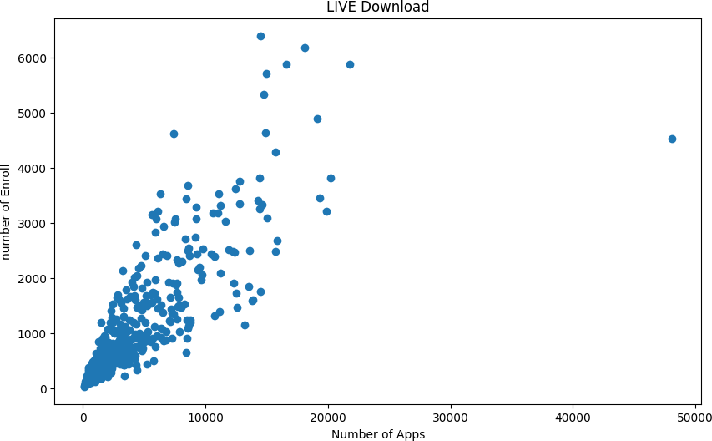

# Declare feature vector and target variable

In [19]:

df.head(2)

Out[19]:

**0**

|  |  |  |  |  |  |  |  |
| --- | --- | --- | --- | --- | --- | --- | --- |
| **Unnamed: Apps** | **Accept** | **Enroll** | **Top10perc** | **Top25perc** | **F.Undergrad** | **P.Undergrad** | **Outs** |
| Abilene  **0** Christian 1660 University | 1232 | 721 | 23 | 52 | 2885 | 537 | 7 |
| **1** Adelphi 2186 | 1924 | 512 | 16 | 29 | 2683 | 1227 | 12 |

University

# Convert categorical variable into integers

In [20]:

**from** sklearn.preprocessing **import** LabelEncoder le **=** LabelEncoder()

df['Unnamed: 0'] **=** le.fit_transform(df['Unnamed: 0'])

In [22]:

y**=**df

cols **=** y.columns

**from** sklearn.preprocessing **import** MinMaxScaler ms **=** MinMaxScaler()

y **=** ms.fit_transform(y)

y **=** pd.DataFrame(y, columns**=**[cols])

In [23]:

X **=** y.values

X[:5] *# Show first 5 records only*

Out[23]:

array([[0. , 0.03288693, 0.04417701, 0.10791254, 0.23157895,

|  |  |  |  |  |
| --- | --- | --- | --- | --- |
| 0.47252747, | 0.08716353, | 0.02454774, | 0.26342975, | 0.23959647, |
| 0.15775401, | 0.29770992, | 0.65263158, | 0.71052632], |  |
| [0.00128866, | 0.04384229, | 0.07053089, | 0.07503539, | 0.15789474, |
| 0.21978022, | 0.08075165, | 0.05614839, | 0.51342975, | 0.73612863, |
| 0.29144385, | 0.19083969, | 0.22105263, | 0.07894737], |  |
| [0.00257732, | 0.0280549 , | 0.03903572, | 0.04734938, | 0.22105263, |
| 0.45054945, | 0.02847257, | 0.00448821, | 0.46022727, | 0.31052963, |
| 0.13547237, | 0.13969466, | 0.47368421, | 0.55263158], |  |
| [0.00386598, | 0.0069981 , | 0.01054917, | 0.0160453 , | 0.62105263, |
| 0.87912088, | 0.01177628, | 0.00283948, | 0.54855372, | 0.57849937, |
| 0.15775401, | 0.09541985, | 0.88421053, | 0.96052632], |  |
| [0.00515464, | 0.0023327 , | 0.00281819, | 0.00314614, | 0.15789474, |
| 0.38461538, | 0.00349162, | 0.03975269, | 0.2696281 , | 0.36885246, |

0.31372549, 0.19083969, 0.71578947, 0.63157895]])

# Feature Scaling

In [25]:

**from** sklearn.cluster **import** KMeans clustering_score **=** []

**for** i **in** range(1, 11):

kmeans **=** KMeans(n_clusters **=** i, init **=** 'random', random_state **=** 42) kmeans.fit(X)

clustering_score.append(kmeans.inertia_)

plt.figure(figsize**=**(10,6))

plt.plot(range(1, 11), clustering_score)

plt.scatter(4,clustering_score[3], s **=** 200, c **=** 'red', marker**=**'*') plt.title('The Elbow Method')

plt.xlabel('No. of Clusters') plt.ylabel('Clustering Score') plt.show()

c:\Users\USER\AppData\Local\Programs\Python\Python39\lib\site-packages\sk learn\cluster\_kmeans.py:1412: FutureWarning: The default value of `n_ini t` will change from 10 to 'auto' in 1.4. Set the value of `n_init` explic itly to suppress the warning

super()._check_params_vs_input(X, default_n_init=10)

c:\Users\USER\AppData\Local\Programs\Python\Python39\lib\site-packages\sk learn\cluster\_kmeans.py:1412: FutureWarning: The default value of `n_ini t` will change from 10 to 'auto' in 1.4. Set the value of `n_init` explic itly to suppress the warning

super()._check_params_vs_input(X, default_n_init=10)

c:\Users\USER\AppData\Local\Programs\Python\Python39\lib\site-packages\sk learn\cluster\_kmeans.py:1412: FutureWarning: The default value of `n_ini t` will change from 10 to 'auto' in 1.4. Set the value of `n_init` explic itly to suppress the warning

super()._check_params_vs_input(X, default_n_init=10)

c:\Users\USER\AppData\Local\Programs\Python\Python39\lib\site-packages\sk learn\cluster\_kmeans.py:1412: FutureWarning: The default value of `n_ini t` will change from 10 to 'auto' in 1.4. Set the value of `n_init` explic itly to suppress the warning

super()._check_params_vs_input(X, default_n_init=10)

c:\Users\USER\AppData\Local\Programs\Python\Python39\lib\site-packages\sk learn\cluster\_kmeans.py:1412: FutureWarning: The default value of `n_ini t` will change from 10 to 'auto' in 1.4. Set the value of `n_init` explic itly to suppress the warning

super()._check_params_vs_input(X, default_n_init=10)

c:\Users\USER\AppData\Local\Programs\Python\Python39\lib\site-packages\sk learn\cluster\_kmeans.py:1412: FutureWarning: The default value of `n_ini t` will change from 10 to 'auto' in 1.4. Set the value of `n_init` explic itly to suppress the warning

super()._check_params_vs_input(X, default_n_init=10)

c:\Users\USER\AppData\Local\Programs\Python\Python39\lib\site-packages\sk learn\cluster\_kmeans.py:1412: FutureWarning: The default value of `n_ini t` will change from 10 to 'auto' in 1.4. Set the value of `n_init` explic itly to suppress the warning

super()._check_params_vs_input(X, default_n_init=10)

c:\Users\USER\AppData\Local\Programs\Python\Python39\lib\site-packages\sk learn\cluster\_kmeans.py:1412: FutureWarning: The default value of `n_ini t` will change from 10 to 'auto' in 1.4. Set the value of `n_init` explic itly to suppress the warning

super()._check_params_vs_input(X, default_n_init=10)

c:\Users\USER\AppData\Local\Programs\Python\Python39\lib\site-packages\sk learn\cluster\_kmeans.py:1412: FutureWarning: The default value of `n_ini t` will change from 10 to 'auto' in 1.4. Set the value of `n_init` explic itly to suppress the warning

super()._check_params_vs_input(X, default_n_init=10)

c:\Users\USER\AppData\Local\Programs\Python\Python39\lib\site-packages\sk learn\cluster\_kmeans.py:1412: FutureWarning: The default value of `n_ini t` will change from 10 to 'auto' in 1.4. Set the value of `n_init` explic itly to suppress the warning

super()._check_params_vs_input(X, default_n_init=10)

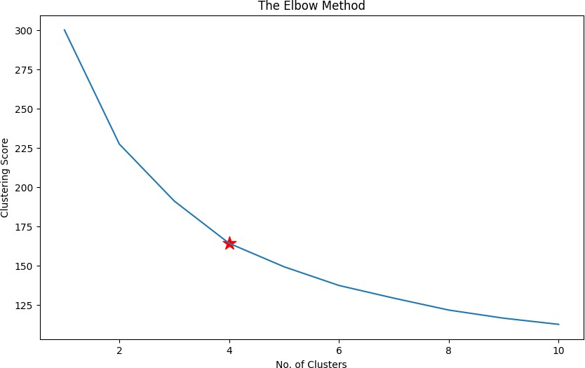

# K-Means model with five clusters

In [26]:

kmeans**=** KMeans(n_clusters **=** 5, random_state **=** 42)

*# Compute k-means clustering*

kmeans.fit(X)

*# Compute cluster centers and predict cluster index for each sample.*

pred **=** kmeans.predict(X) pred

c:\Users\USER\AppData\Local\Programs\Python\Python39\lib\site-packages\sk learn\cluster\_kmeans.py:1412: FutureWarning: The default value of `n_ini t` will change from 10 to 'auto' in 1.4. Set the value of `n_init` explic itly to suppress the warning

super()._check_params_vs_input(X, default_n_init=10)

|  |  |  |  |  |  |  |  |  |  |  |  |  |  |  |  |  |  |  |  |  |  |
| --- | --- | --- | --- | --- | --- | --- | --- | --- | --- | --- | --- | --- | --- | --- | --- | --- | --- | --- | --- | --- | --- |
| Out[26]: |  | | | | | | | | | | | | | | | | | | | | |
| array([0, | 0, | 0, | 2, | 0, | 0, | 2, | 2, | 2, | 0, | 2, | 2, | 2, | 2, | 0, | 0, | 2, | 0, | 0, | 0, | 0, | 0, |
| 0, | 4, | 2, | 0, | 2, | 4, | 0, | 2, | 0, | 2, | 0, | 0, | 0, | 0, | 2, | 2, | 0, | 0, | 2, | 0, | 0, | 0, |
| 2, | 0, | 0, | 0, | 2, | 0, | 0, | 0, | 0, | 0, | 2, | 0, | 0, | 0, | 0, | 2, | 2, | 4, | 0, | 2, | 2, | 0, |
| 0, | 0, | 0, | 4, | 2, | 2, | 2, | 0, | 2, | 0, | 0, | 0, | 2, | 0, | 0, | 0, | 0, | 0, | 0, | 0, | 2, | 2, |
| 0, | 0, | 0, | 2, | 0, | 0, | 2, | 0, | 2, | 0, | 0, | 2, | 0, | 2, | 0, | 0, | 0, | 0, | 2, | 2, | 2, | 0, |
| 2, | 0, | 0, | 0, | 2, | 2, | 0, | 2, | 4, | 0, | 2, | 0, | 2, | 2, | 0, | 0, | 0, | 0, | 0, | 0, | 2, | 0, |
| 0, | 0, | 0, | 0, | 0, | 2, | 2, | 2, | 2, | 4, | 0, | 0, | 2, | 0, | 0, | 0, | 0, | 2, | 0, | 2, | 2, | 0, |
| 0, | 0, | 0, | 0, | 2, | 2, | 0, | 0, | 2, | 2, | 2, | 0, | 0, | 0, | 0, | 0, | 0, | 2, | 2, | 2, | 2, | 2, |
| 4, | 0, | 0, | 0, | 0, | 0, | 0, | 0, | 2, | 2, | 2, | 0, | 0, | 0, | 2, | 2, | 0, | 2, | 0, | 0, | 2, | 0, |
| 0, | 0, | 2, | 4, | 0, | 4, | 0, | 2, | 0, | 0, | 0, | 0, | 0, | 0, | 0, | 2, | 0, | 0, | 0, | 0, | 2, | 2, |
| 0, | 2, | 2, | 0, | 0, | 2, | 0, | 2, | 0, | 0, | 2, | 0, | 0, | 0, | 0, | 0, | 0, | 2, | 0, | 2, | 2, | 0, |
| 2, | 2, | 2, | 0, | 2, | 0, | 0, | 2, | 2, | 2, | 0, | 2, | 2, | 2, | 2, | 2, | 2, | 2, | 2, | 2, | 0, | 0, |
| 0, | 0, | 0, | 0, | 2, | 4, | 2, | 0, | 0, | 0, | 4, | 0, | 0, | 4, | 2, | 4, | 0, | 0, | 0, | 2, | 2, | 0, |
| 0, | 2, | 4, | 0, | 0, | 0, | 2, | 0, | 0, | 0, | 2, | 0, | 2, | 2, | 0, | 2, | 0, | 0, | 0, | 0, | 2, | 2, |
| 2, | 2, | 2, | 0, | 0, | 2, | 0, | 0, | 0, | 0, | 2, | 0, | 0, | 0, | 0, | 0, | 4, | 0, | 2, | 2, | 2, | 2, |
| 2, | 0, | 0, | 0, | 2, | 0, | 0, | 0, | 2, | 2, | 0, | 0, | 2, | 3, | 2, | 4, | 2, | 2, | 3, | 0, | 3, | 2, |
| 0, | 0, | 1, | 0, | 0, | 0, | 0, | 2, | 0, | 3, | 3, | 0, | 3, | 4, | 4, | 2, | 0, | 3, | 0, | 3, | 2, | 0, |
| 3, | 3, | 0, | 0, | 0, | 2, | 3, | 3, | 3, | 3, | 0, | 3, | 2, | 3, | 0, | 0, | 1, | 0, | 0, | 0, | 0, | 3, |
| 3, | 2, | 2, | 0, | 2, | 3, | 3, | 3, | 2, | 2, | 2, | 1, | 0, | 1, | 3, | 3, | 4, | 3, | 1, | 3, | 3, | 3, |
| 4, | 4, | 4, | 3, | 3, | 3, | 1, | 3, | 0, | 3, | 1, | 1, | 1, | 2, | 4, | 1, | 3, | 3, | 4, | 3, | 3, | 3, |
| 1, | 1, | 3, | 1, | 3, | 4, | 1, | 3, | 3, | 3, | 3, | 3, | 3, | 1, | 3, | 3, | 1, | 3, | 3, | 1, | 3, | 4, |
| 3, | 3, | 3, | 3, | 3, | 3, | 1, | 1, | 3, | 1, | 1, | 3, | 1, | 3, | 1, | 3, | 3, | 3, | 1, | 3, | 3, | 4, |
| 1, | 3, | 3, | 3, | 3, | 3, | 3, | 3, | 3, | 3, | 3, | 1, | 3, | 1, | 1, | 3, | 3, | 1, | 1, | 3, | 3, | 1, |
| 3, | 3, | 3, | 3, | 4, | 1, | 1, | 3, | 3, | 1, | 1, | 1, | 3, | 3, | 3, | 3, | 3, | 3, | 1, | 3, | 3, | 1, |
| 1, | 3, | 3, | 3, | 3, | 3, | 1, | 3, | 4, | 3, | 3, | 3, | 1, | 3, | 1, | 3, | 3, | 3, | 3, | 1, | 3, | 1, |
| 1, | 3, | 3, | 3, | 3, | 3, | 1, | 1, | 3, | 1, | 4, | 4, | 4, | 4, | 3, | 3, | 3, | 3, | 3, | 1, | 3, | 3, |
| 3, | 3, | 1, | 1, | 1, | 3, | 3, | 3, | 3, | 4, | 3, | 3, | 3, | 4, | 3, | 3, | 3, | 3, | 1, | 1, | 3, | 1, |
| 1, | 3, | 1, | 1, | 3, | 3, | 3, | 1, | 3, | 3, | 4, | 4, | 1, | 4, | 3, | 1, | 4, | 4, | 1, | 3, | 4, | 1, |
| 3, | 3, | 3, | 4, | 4, | 3, | 4, | 4, | 4, | 3, | 4, | 3, | 4, | 3, | 3, | 3, | 3, | 4, | 4, | 3, | 1, | 4, |
| 3, | 1, | 4, | 3, | 4, | 1, | 3, | 3, | 3, | 4, | 3, | 4, | 3, | 4, | 4, | 3, | 3, | 4, | 1, | 4, | 3, | 4, |
| 1, | 4, | 4, | 1, | 4, | 1, | 1, | 4, | 1, | 1, | 1, | 1, | 3, | 1, | 3, | 4, | 4, | 1, | 3, | 3, | 3, | 3, |
| 1, | 4, | 3, | 4, | 4, | 3, | 1, | 1, | 1, | 4, | 1, | 1, | 4, | 3, | 3, | 3, | 3, | 3, | 4, | 4, | 3, | 3, |
| 1, | 3, | 3, | 1, | 1, | 1, | 1, | 4, | 3, | 4, | 3, | 3, | 3, | 3, | 1, | 3, | 1, | 3, | 3, | 3, | 1, | 1, |
| 1, | 4, | 1, | 3, | 3, | 3, | 3, | 1, | 1, | 3, | 3, | 1, | 3, | 3, | 3, | 3, | 1, | 4, | 3, | 3, | 4, | 3, |
| 3, | 3, | 3, | 1, | 1, | 1, | 3, | 1, | 1, | 1, | 1, | 3, | 1, | 3, | 3, | 1, | 3, | 3, | 3, | 3, | 3, | 1, |
| 1, | 1, | 3, | 3, | 3, | 1, | 3]) |  |  |  |  |  |  |  |  |  |  |  |  |  |  |  |

In [27]:

df['Cluster'] **=** pd.DataFrame(pred, columns**=**['cluster'] )

print('Number of data points in each cluster= \n', df['Cluster'].value_counts()) df

Number of data points in each cluster=

|  |  |  |
| --- | --- | --- |
|  | 0 | 226 |
| 3 |  | 219 |
| 2 |  | 143 |
| 1 |  | 111 |
| 4 |  | 78 |

Name: Cluster, dtype: int64

Out[27]:

**Unnamed:**

**0**

**Apps Accept Enroll Top10perc Top25perc F.Undergrad P.Undergrad O**

**0** 0 1660 1232 721 23 52 2885 537

**1** 1 2186 1924 512 16 29 2683 1227

**2** 2 1428 1097 336 22 50 1036 99

**3** 3 417 349 137 60 89 510 63

**4** 4 193 146 55 16 44 249 869

**...** ... ... ... ... ... ... ... ...

**772** 772 2197 1515 543 4 26 3089 2029

**773** 773 1959 1805 695 24 47 2849 1107

**774** 774 2097 1915 695 34 61 2793 166

**775** 775 10705 2453 1317 95 99 5217 83

**776** 776 2989 1855 691 28 63 2988 1726

777 rows × 15 columns

# Vizualization

In [28]:

plt.figure(figsize**=**(10,6))

plt.scatter(kmeans.cluster_centers_[:,1], kmeans.cluster_centers_[:, 2],s **=**100, c **=** 'red

plt.xlabel('num_reactions') plt.ylabel('num_comments') plt.legend()

plt.title('Live selling')

|  |  |  |  |  |  |  |  |  |  |  |
| --- | --- | --- | --- | --- | --- | --- | --- | --- | --- | --- |
| plt.scatter(X[pred | **==** | 0, | 3], | X[pred | **==** | 0, | 2], | c | **=** | 'brown', label **=** 'Cluster 0') |
| plt.scatter(X[pred | **==** | 1, | 3], | X[pred | **==** | 1, | 2], | c | **=** | 'green', label **=** 'Cluster 1') |
| plt.scatter(X[pred | **==** | 2, | 3], | X[pred | **==** | 2, | 2], | c | **=** | 'blue', label **=** 'Cluster 2') |
| plt.scatter(X[pred | **==** | 3, | 3], | X[pred | **==** | 3, | 2], | c | **=** | 'purple', label **=** 'Cluster 3') |
| plt.scatter(X[pred | **==** | 4, | 3], | X[pred | **==** | 4, | 2], | c | **=** | 'orange', label **=** 'Cluster 4') |

Out[28]:

Text(0.5, 1.0, 'Live selling')

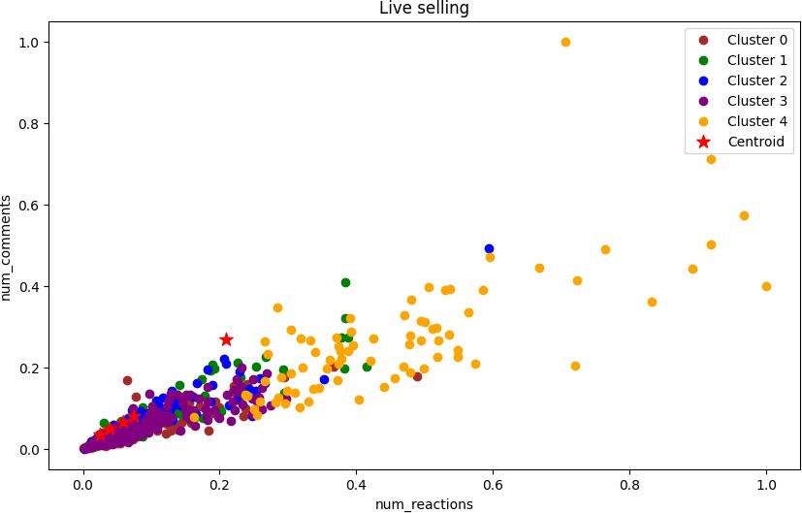

# K-Means model parameters study

In [29]:

labels1 **=** kmeans.labels_

centroids1 **=** kmeans.cluster_centers_ labels1

Out[29]:

|  |  |  |  |  |  |  |  |  |  |  |  |  |  |  |  |  |  |  |  |  |  |
| --- | --- | --- | --- | --- | --- | --- | --- | --- | --- | --- | --- | --- | --- | --- | --- | --- | --- | --- | --- | --- | --- |
| array([0, | 0, | 0, | 2, | 0, | 0, | 2, | 2, | 2, | 0, | 2, | 2, | 2, | 2, | 0, | 0, | 2, | 0, | 0, | 0, | 0, | 0, |
| 0, | 4, | 2, | 0, | 2, | 4, | 0, | 2, | 0, | 2, | 0, | 0, | 0, | 0, | 2, | 2, | 0, | 0, | 2, | 0, | 0, | 0, |
| 2, | 0, | 0, | 0, | 2, | 0, | 0, | 0, | 0, | 0, | 2, | 0, | 0, | 0, | 0, | 2, | 2, | 4, | 0, | 2, | 2, | 0, |
| 0, | 0, | 0, | 4, | 2, | 2, | 2, | 0, | 2, | 0, | 0, | 0, | 2, | 0, | 0, | 0, | 0, | 0, | 0, | 0, | 2, | 2, |
| 0, | 0, | 0, | 2, | 0, | 0, | 2, | 0, | 2, | 0, | 0, | 2, | 0, | 2, | 0, | 0, | 0, | 0, | 2, | 2, | 2, | 0, |
| 2, | 0, | 0, | 0, | 2, | 2, | 0, | 2, | 4, | 0, | 2, | 0, | 2, | 2, | 0, | 0, | 0, | 0, | 0, | 0, | 2, | 0, |
| 0, | 0, | 0, | 0, | 0, | 2, | 2, | 2, | 2, | 4, | 0, | 0, | 2, | 0, | 0, | 0, | 0, | 2, | 0, | 2, | 2, | 0, |
| 0, | 0, | 0, | 0, | 2, | 2, | 0, | 0, | 2, | 2, | 2, | 0, | 0, | 0, | 0, | 0, | 0, | 2, | 2, | 2, | 2, | 2, |
| 4, | 0, | 0, | 0, | 0, | 0, | 0, | 0, | 2, | 2, | 2, | 0, | 0, | 0, | 2, | 2, | 0, | 2, | 0, | 0, | 2, | 0, |
| 0, | 0, | 2, | 4, | 0, | 4, | 0, | 2, | 0, | 0, | 0, | 0, | 0, | 0, | 0, | 2, | 0, | 0, | 0, | 0, | 2, | 2, |
| 0, | 2, | 2, | 0, | 0, | 2, | 0, | 2, | 0, | 0, | 2, | 0, | 0, | 0, | 0, | 0, | 0, | 2, | 0, | 2, | 2, | 0, |
| 2, | 2, | 2, | 0, | 2, | 0, | 0, | 2, | 2, | 2, | 0, | 2, | 2, | 2, | 2, | 2, | 2, | 2, | 2, | 2, | 0, | 0, |
| 0, | 0, | 0, | 0, | 2, | 4, | 2, | 0, | 0, | 0, | 4, | 0, | 0, | 4, | 2, | 4, | 0, | 0, | 0, | 2, | 2, | 0, |
| 0, | 2, | 4, | 0, | 0, | 0, | 2, | 0, | 0, | 0, | 2, | 0, | 2, | 2, | 0, | 2, | 0, | 0, | 0, | 0, | 2, | 2, |
| 2, | 2, | 2, | 0, | 0, | 2, | 0, | 0, | 0, | 0, | 2, | 0, | 0, | 0, | 0, | 0, | 4, | 0, | 2, | 2, | 2, | 2, |
| 2, | 0, | 0, | 0, | 2, | 0, | 0, | 0, | 2, | 2, | 0, | 0, | 2, | 3, | 2, | 4, | 2, | 2, | 3, | 0, | 3, | 2, |
| 0, | 0, | 1, | 0, | 0, | 0, | 0, | 2, | 0, | 3, | 3, | 0, | 3, | 4, | 4, | 2, | 0, | 3, | 0, | 3, | 2, | 0, |
| 3, | 3, | 0, | 0, | 0, | 2, | 3, | 3, | 3, | 3, | 0, | 3, | 2, | 3, | 0, | 0, | 1, | 0, | 0, | 0, | 0, | 3, |
| 3, | 2, | 2, | 0, | 2, | 3, | 3, | 3, | 2, | 2, | 2, | 1, | 0, | 1, | 3, | 3, | 4, | 3, | 1, | 3, | 3, | 3, |
| 4, | 4, | 4, | 3, | 3, | 3, | 1, | 3, | 0, | 3, | 1, | 1, | 1, | 2, | 4, | 1, | 3, | 3, | 4, | 3, | 3, | 3, |
| 1, | 1, | 3, | 1, | 3, | 4, | 1, | 3, | 3, | 3, | 3, | 3, | 3, | 1, | 3, | 3, | 1, | 3, | 3, | 1, | 3, | 4, |
| 3, | 3, | 3, | 3, | 3, | 3, | 1, | 1, | 3, | 1, | 1, | 3, | 1, | 3, | 1, | 3, | 3, | 3, | 1, | 3, | 3, | 4, |
| 1, | 3, | 3, | 3, | 3, | 3, | 3, | 3, | 3, | 3, | 3, | 1, | 3, | 1, | 1, | 3, | 3, | 1, | 1, | 3, | 3, | 1, |
| 3, | 3, | 3, | 3, | 4, | 1, | 1, | 3, | 3, | 1, | 1, | 1, | 3, | 3, | 3, | 3, | 3, | 3, | 1, | 3, | 3, | 1, |
| 1, | 3, | 3, | 3, | 3, | 3, | 1, | 3, | 4, | 3, | 3, | 3, | 1, | 3, | 1, | 3, | 3, | 3, | 3, | 1, | 3, | 1, |
| 1, | 3, | 3, | 3, | 3, | 3, | 1, | 1, | 3, | 1, | 4, | 4, | 4, | 4, | 3, | 3, | 3, | 3, | 3, | 1, | 3, | 3, |
| 3, | 3, | 1, | 1, | 1, | 3, | 3, | 3, | 3, | 4, | 3, | 3, | 3, | 4, | 3, | 3, | 3, | 3, | 1, | 1, | 3, | 1, |
| 1, | 3, | 1, | 1, | 3, | 3, | 3, | 1, | 3, | 3, | 4, | 4, | 1, | 4, | 3, | 1, | 4, | 4, | 1, | 3, | 4, | 1, |
| 3, | 3, | 3, | 4, | 4, | 3, | 4, | 4, | 4, | 3, | 4, | 3, | 4, | 3, | 3, | 3, | 3, | 4, | 4, | 3, | 1, | 4, |
| 3, | 1, | 4, | 3, | 4, | 1, | 3, | 3, | 3, | 4, | 3, | 4, | 3, | 4, | 4, | 3, | 3, | 4, | 1, | 4, | 3, | 4, |
| 1, | 4, | 4, | 1, | 4, | 1, | 1, | 4, | 1, | 1, | 1, | 1, | 3, | 1, | 3, | 4, | 4, | 1, | 3, | 3, | 3, | 3, |
| 1, | 4, | 3, | 4, | 4, | 3, | 1, | 1, | 1, | 4, | 1, | 1, | 4, | 3, | 3, | 3, | 3, | 3, | 4, | 4, | 3, | 3, |
| 1, | 3, | 3, | 1, | 1, | 1, | 1, | 4, | 3, | 4, | 3, | 3, | 3, | 3, | 1, | 3, | 1, | 3, | 3, | 3, | 1, | 1, |
| 1, | 4, | 1, | 3, | 3, | 3, | 3, | 1, | 1, | 3, | 3, | 1, | 3, | 3, | 3, | 3, | 1, | 4, | 3, | 3, | 4, | 3, |
| 3, | 3, | 3, | 1, | 1, | 1, | 3, | 1, | 1, | 1, | 1, | 3, | 1, | 3, | 3, | 1, | 3, | 3, | 3, | 3, | 3, | 1, |
| 1, | 1, | 3, | 3, | 3, | 1, | 3]) |  |  |  |  |  |  |  |  |  |  |  |  |  |  |  |

In [30]:

kmeans.inertia_

Out[30]:

149.2353098465791